Mini Quiz Application

Zhenghao Zhang
900877849
CSC4330
Dr. Sonipriya Paul

4/30/2025
https://github.com/stevenzhang6/mini-quiz-app
1 Abstract
This project introduces Mini Quiz, a multiplayer quiz game created with Python and the Tkinter library. The goal of the project was to apply key programming language concepts by building an interactive and functional application. Players take turns answering five randomly selected questions, each with a 20-second timer. The scoring system rewards both accuracy and speed, with base points based on difficulty and bonus points for quick answers.
All quiz questions are loaded from a JSON file, and player scores are stored in a separate JSONL file so that leaderboard history is preserved even after the program ends. The game also features a graphical interface that handles user input, timing, and feedback in real time.
Throughout the development process, I made use of loops, conditional statements, functions, and simple object-oriented design. The timer system and score calculation required careful use of control flow and logic. Although dynamic difficulty adjustment was not included due to the small number of questions, the project structure allows for future upgrades. Overall, this project was a practical way to explore how Python programming concepts come together in a complete application.

2 Introduction
Quizzes are a popular and effective way to test knowledge and engage learners. With the growing interest in interactive learning tools, building a quiz application seemed like a meaningful and practical project. This idea also provided a good opportunity to apply and reinforce the programming language concepts learned throughout the course.
The main problem this project aims to solve is how to design a simple, fun, and educational quiz game that allows multiple players to participate, tracks performance, and provides immediate feedback. At the same time, the project needed to reflect core programming principles in areas like logic control, file handling, and modular design.
The primary goal of this project was to create a working multiplayer quiz application using Python. It needed to load questions from an external file, handle user input through a graphical interface, calculate scores based on both speed and difficulty, and keep track of a persistent leaderboard. The program was also designed to be clear, user-friendly, and easy to extend in the future.

3 Related Work / Literature Review
There are many existing quiz applications available today, both online and offline. Popular platforms like Kahoot and Quizizz provide engaging multiplayer quiz experiences and are widely used in classrooms and training environments. These systems often feature real-time feedback, large question databases, and adaptive difficulty. However, they typically rely on web technologies and an internet connection.

4 Design & Methodology
This project is a multiplayer quiz game built with Python and Tkinter for the interface. The game uses an object-oriented design, with a main QuizApp class that keeps everything organized, from game logic to user interactions. Python was a good fit for this project because it’s easy to work with and perfect for building something quickly but clearly.
Players take turns answering the same five randomly chosen questions. The game supports both fill-in-the-blank and multiple-choice questions, with a 20-second timer and extra points for faster answers. All questions come from a JSON file, and scores are saved to a JSONL file so they don’t disappear when the game ends.
The overall design is simple on purpose. Everything runs through Tkinter widgets, and countdowns are handled with after() calls to keep the flow smooth. Even though the current version is local and turn-based, the setup makes it easy to add more features later, like online multiplayer or more structured data handling.

5 Implementation
The project was implemented entirely in Python using the Tkinter library for the graphical user interface. JSON and JSONL files were used to store questions and leaderboard data, making the app lightweight and easy to manage without needing a database.
The core of the project is organized in a single QuizApp class, which contains all the major components such as player setup, question rendering, timer handling, score calculation, and leaderboard storage. One important part of the implementation was the use of after() in Tkinter, which allowed for a smooth 20-second countdown without blocking the rest of the interface.
For example, the quiz used a simple if-else chain to calculate time-based bonus points:
To display multiple-choice options dynamically, a loop was used with enumerate():
Another important part of this project is how it uses object-oriented programming. The entire quiz logic is wrapped inside a class called QuizApp, which makes the code more organized and easier to manage. As shown in the image, each part of the game logic is handled by a separate method inside this class, like setting up players, showing the next question, starting a countdown, and updating the timer. By grouping these related functions together, it is easier to track the game’s state and reuse components. It also makes the app easier to extend in the future, for example by adding a Player class or more question types.
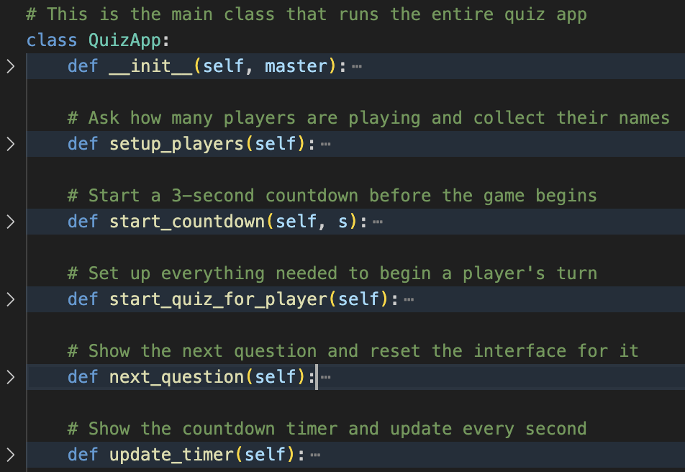
One challenge was making sure the leaderboard was persistent between sessions. This was solved by appending game results to a .jsonl file, then reading and formatting them when the user clicks “View History.”
Another challenge involved managing turn-based play between multiple users while keeping the same five randomly chosen questions for all players. This required careful handling of shared state, timers, and transitions between players.
Overall, the app stayed lightweight while still covering a wide range of programming language concepts.

6 Evaluation & Results
To evaluate how well the quiz application works, I tested the full experience from start to finish. This included starting a new game, entering different numbers of players, answering various types of questions, and reviewing scores. The timer, scoring system, and user interface all worked together smoothly.
When the game launches, it shows a welcome screen with clear instructions on how the quiz works, including the time limit and scoring system
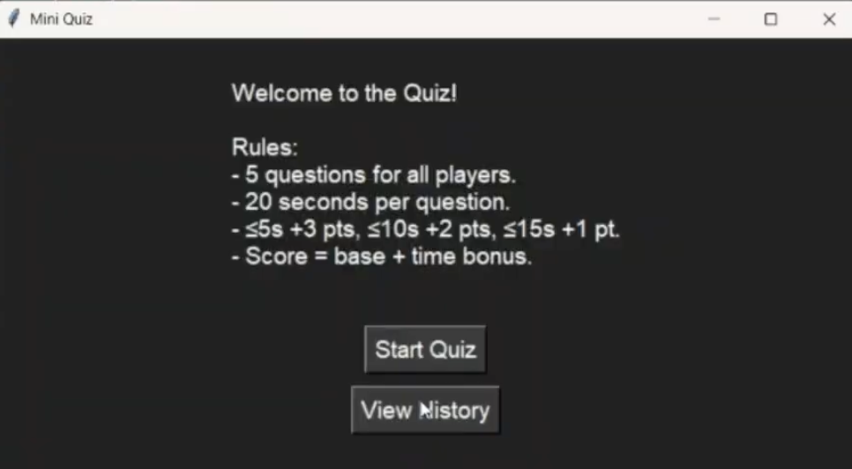
After clicking “Start Quiz,” the app prompts for how many players are joining. This allows for a flexible setup depending on how many people are playing
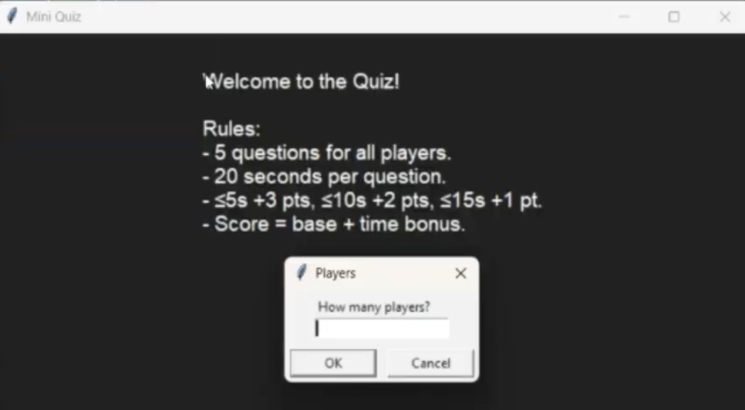
As players answer questions, the app provides instant feedback on whether the answer was right or wrong, including a breakdown of base points and time bonus
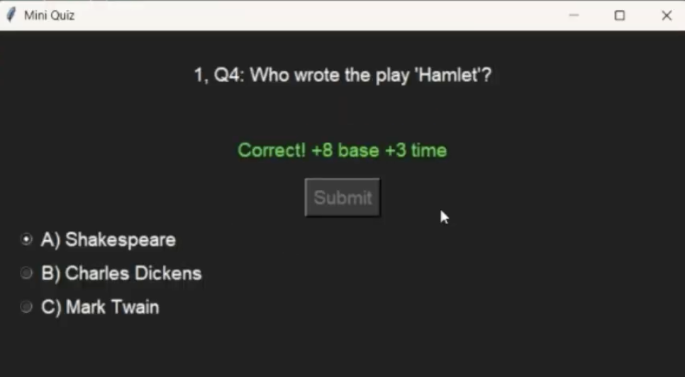
Finally, users can click “View History” to open a window showing the most recent results saved from previous games. This helps track performance across sessions
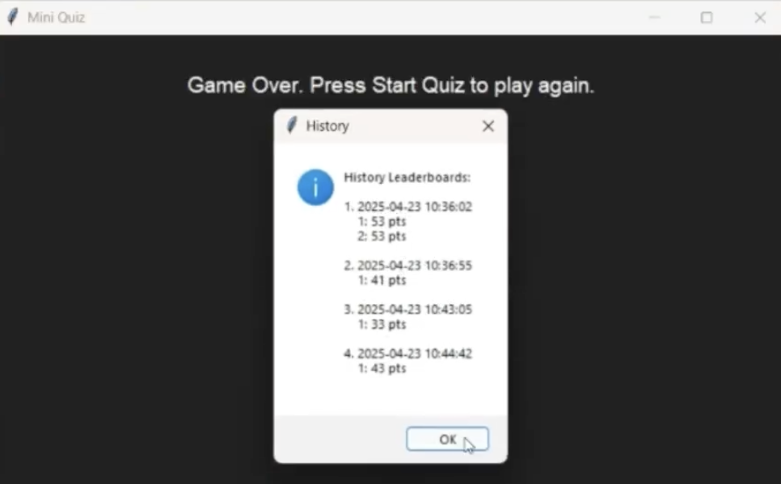
Overall, the app runs reliably, with accurate scoring and a clean interface. A highlight is how leaderboard data is stored across runs, making results persistent. One limitation is that the question pool is still small, which can lead to repetition in multiple rounds.

7 Discussion
One of the strongest parts of this project is how well the different pieces came together. The GUI, timer, scoring, and file storage all worked smoothly, and the flow between questions and players felt clear and responsive. The game logic was simple to understand and consistent across rounds, which helped a lot during testing.
Using Python was a great choice for this project. It allowed me to quickly build a functional app and focus on logic without worrying too much about syntax. Tkinter, as a built-in GUI library, was easy to get started with and gave me enough flexibility to build something that looked clean and worked well.
The object-oriented approach also helped structure the project in a way that was manageable. Keeping all the functions and data inside a class made it easier to control state and handle events. I could clearly separate player logic, question handling, and UI updates within the same class.
Compared to other ways of building a quiz, like using a web app framework or a purely command-line interface, this version strikes a good balance between simplicity and usability. It does not require internet access or a browser and still provides a more visual and interactive experience than a terminal app.

8 Conclusion & Future Work
This project successfully delivered a fully working multiplayer quiz game with a user-friendly interface and an automated scoring system. The application handles timed questions, tracks multiple players, and stores past leaderboard results. It runs smoothly from start to finish and provides clear feedback for each answer, which makes the experience engaging and easy to follow.
While the core features were implemented effectively, there are still areas for future improvement. Expanding the question pool would allow for more dynamic difficulty balancing, giving the game a better sense of progression. Another major upgrade would be turning the app into an online quiz platform, where users could play remotely and leaderboard data could be stored in a database rather than local files.
Through this project, I became more comfortable with using Tkinter for building GUI applications and learned the value of organizing a project using object-oriented programming. I also gained a deeper appreciation for how user input, timers, and file handling can all come together to make an interactive and functional Python app.

9 References
Galitz, W. O. (2007). The Essential Guide to User Interface Design: An introduction to GUI design principles and Techniques. Wiley Pub.
Sebesta, R. W. (2016a). Concepts of programming languages. Pearson.
10 Appendix
Full code:
# Bring in all the tools we need: GUI, dialog boxes, random stuff, timing, and reading JSON files
import tkinter as tk
from tkinter import simpledialog, messagebox
import random, time, json

# Load questions and choose 5 random ones for the whole game
all_questions = json.load(open("questions.json", encoding="utf-8"))
shared_quiz_questions = random.sample(all_questions, 5)
difficulty_scores = {"easy": 6, "medium": 8, "hard": 10}

# This is the main class that runs the entire quiz app
class QuizApp:
def __init__(self, master):
# Set up the main window and its look
self.master = master
master.title("Mini Quiz")
master.geometry("700x500")
master.configure(bg="#1e1e1e")

# Set up game state and main labels/buttons
self.players, self.scores, self.current_player_index = [], {}, 0
self.label = tk.Label(master, text="""Welcome to the Quiz!\n\nRules:\n- 5 questions for all players.\n- 20 seconds per question.\n- ≤5s +3 pts, ≤10s +2 pts, ≤15s +1 pt.\n- Score = base + time bonus.""", font=("Arial", 14), wraplength=650, justify="left", fg="white", bg="#1e1e1e")
self.label.pack(pady=(30, 10))
self.timer_label = tk.Label(master, font=("Arial", 14), fg="orange", bg="#1e1e1e")
self.timer_label.pack()

# Set up answer input options: text box and radio buttons
self.answer_var = tk.StringVar()
self.answer_entry = tk.Entry(master, textvariable=self.answer_var, font=("Arial", 14))
self.radio_buttons = [tk.Radiobutton(master, variable=self.answer_var, font=("Arial", 14), anchor='w', justify='left', fg="white", bg="#1e1e1e", selectcolor="#333333") for _ in range(4)]

# Buttons for starting quiz and viewing leaderboard history
self.submit_button = tk.Button(master, text="Start Quiz", font=("Arial", 14), command=self.setup_players, bg="#333333", fg="white")
self.submit_button.pack(pady=5)
self.view_history_button = tk.Button(master, text="View History", font=("Arial", 14), command=self.view_leaderboard_history, bg="#333333", fg="white")
self.view_history_button.pack(pady=5)
self.feedback_label = tk.Label(master, font=("Arial", 14), fg="#44ff44", bg="#1e1e1e")
self.feedback_label.pack(pady=10)
self.timer_id = self.remaining_time = 0

# Ask how many players are playing and collect their names
def setup_players(self):
num_players = simpledialog.askinteger("Players", "How many players?", parent=self.master, minvalue=1, maxvalue=10)
if num_players:
self.players, self.scores = [], {}
for i in range(num_players):
name = simpledialog.askstring("Player Name", f"Enter name for Player {i + 1}:", parent=self.master)
if name: self.players.append(name); self.scores[name] = 0
self.current_player_index = 0
self.start_countdown(3)

# Start a 3-second countdown before the game begins
def start_countdown(self, s):
self.label.config(text=f"Starting in {s}...")
self.submit_button.pack_forget()
self.master.after(1000, self.start_countdown, s - 1) if s > 0 else self.start_quiz_for_player()

# Set up everything needed to begin a player's turn
def start_quiz_for_player(self):
self.view_history_button.pack_forget()
self.score = self.current_question_index = self.correct_answers_in_a_row = 0
self.quiz_questions = shared_quiz_questions.copy()
self.current_player = self.players[self.current_player_index]
self.label.config(text=f"{self.current_player}, your turn!")
self.master.after(1000, self.next_question)

# Show the next question and reset the interface for it
def next_question(self):
self.answer_entry.pack_forget()
[rb.pack_forget() for rb in self.radio_buttons]
if self.current_question_index < len(self.quiz_questions):
self.current = self.quiz_questions[self.current_question_index]
self.label.config(text=f"{self.current_player}, Q{self.current_question_index+1}: {self.current['question']}")
self.answer_var.set("")
self.start_time = time.time()
if self.current["type"] == "fill": self.answer_entry.pack(pady=5)
else:
for i, opt in enumerate(self.current.get("options", [])):
self.radio_buttons[i].config(text=opt, value=opt[0]); self.radio_buttons[i].pack(anchor='w', padx=20)
self.submit_button.config(text="Submit", command=self.check_answer)
self.submit_button.pack(pady=5)
self.remaining_time = 20
self.update_timer()
else: self.end_turn()

# Show the countdown timer and update every second
def update_timer(self):
self.timer_label.config(text=f"Time left: {self.remaining_time} seconds")
self.remaining_time -= 1
self.timer_id = self.master.after(1000, self.update_timer) if self.remaining_time >= 0 else self.auto_skip_question()

# If the player runs out of time, move to the next question
def auto_skip_question(self):
self.submit_button.config(state="disabled")
self.feedback_label.config(text="Time's up! Moving to next question.")
self.timer_label.config(text="")
self.current_question_index += 1
self.master.after(1500, self.resume_quiz)

# Check the player’s answer and calculate score
def check_answer(self):
if self.timer_id: self.master.after_cancel(self.timer_id)
self.submit_button.config(state="disabled")
self.timer_label.config(text="")
ans = self.answer_var.get().strip().upper()
time_taken = time.time() - self.start_time
base = difficulty_scores.get(self.current["difficulty"], 6)
bonus = 3 if time_taken <= 5 else 2 if time_taken <= 10 else 1 if time_taken <= 15 else 0
if ans == self.current["answer"]:
self.score += base + bonus
self.feedback_label.config(text=f"Correct! +{base} base +{bonus} time")
else:
self.feedback_label.config(text=f"Wrong! Correct: {self.current['answer']}")
self.current_question_index += 1
self.master.after(1500, self.resume_quiz)

# Load the next question after checking or skipping
def resume_quiz(self):
self.submit_button.config(state="normal")
self.feedback_label.config(text="")
self.timer_label.config(text="")
self.next_question()

# Switch to the next player or end the game
def end_turn(self):
self.scores[self.current_player] = self.score
self.current_player_index += 1
self.submit_button.pack_forget()
if self.current_player_index < len(self.players):
self.label.config(text=f"Next up: {self.players[self.current_player_index]}...")
self.master.after(5000, self.start_quiz_for_player)
else: self.show_leaderboard()

# Show final scores, save them to file, and reset the game
def show_leaderboard(self):
self.view_history_button.pack(pady=5)
try:
json.dump({"players": self.players, "scores": self.scores, "timestamp": time.strftime("%Y-%m-%d %H:%M:%S")}, open("leaderboard.jsonl", "a", encoding="utf-8")); open("leaderboard.jsonl", "a").write("\n")
except: pass
lb = "Leaderboard:\n" + "\n".join(f"{n}: {s} points" for n, s in sorted(self.scores.items(), key=lambda x: x[1], reverse=True))
messagebox.showinfo("Quiz Finished", lb)
self.label.config(text="Game Over. Press Start Quiz to play again.")
self.submit_button.config(text="Start Quiz", command=self.setup_players)
self.submit_button.pack(pady=5)
self.answer_var.set(""); self.answer_entry.pack_forget(); [rb.pack_forget() for rb in self.radio_buttons]

# Load and show leaderboard results from past games
def view_leaderboard_history(self):
try:
with open("leaderboard.jsonl", "r", encoding="utf-8") as f:
text = "History Leaderboards:\n\n"
for i, line in enumerate(f.readlines()[-5:], 1):
data = json.loads(line)
text += f"{i}. {data['timestamp']}\n"
text += "\n".join(f" {n}: {s} pts" for n, s in sorted(data['scores'].items(), key=lambda x: x[1], reverse=True)) + "\n\n"
messagebox.showinfo("History", text)
except: messagebox.showinfo("History", "No past leaderboard data found.")

# This launches the app window and runs the main game loop
if __name__ == "__main__":
root = tk.Tk()
w, h = 700, 500
sw, sh = root.winfo_screenwidth(), root.winfo_screenheight()
root.geometry(f"{w}x{h}+{(sw-w)//2}+{(sh-h)//2}")
QuizApp(root)
root.mainloop()

